Deployment Diagram
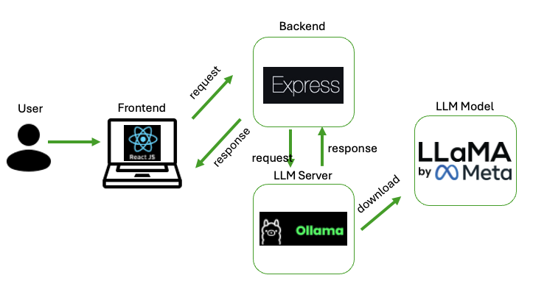

The architecture above allows your app to offer a seamless chat experience with a frontend interface, a backend proxy, and an LLM backend for generating responses.

React
- Frontend Framework: ReactJS is a JavaScript library for building user interfaces, specifically for single-page applications (SPAs). It manages the view layer of the app.
- Component-Based Architecture: React uses components, which are reusable UI elements, to build the interface. This makes it easy to manage complex UIs.
- State Management: React manages the states internally within components or with libraries like Redux, Context API, or other state management tools.
- JSX Syntax: React uses JSX (JavaScript XML), a syntax that lets you write HTML within JavaScript code.

Express
- Backend Framework: Express is a minimal, fast, and flexible Node.js web application framework. It handles the server-side logic of your app.
- Middleware Integration: Express uses middleware functions to handle requests, responses, routing, authentication, etc., making it highly customizable.
- Routing: It manages HTTP request routing, enabling RESTful API design, which allows the frontend to communicate with the backend efficiently.
- Proxy for Services: In your case, Express likely acts as a proxy to communicate with Ollama and handle API interactions, such as sending and receiving data to/from Gemma 2.

Ollama
- LLM Hosting and Management: Ollama is a platform for hosting and managing large language models (LLMs), enabling developers to use models like Gemma 2 in their applications.
- API Endpoint: Ollama typically provides an API endpoint that you can interact with via HTTP requests, making it easier to integrate LLMs into existing apps.
- Use in Chatbots/Assistants: Ollama can be used to provide conversational capabilities or other AI-driven responses, which are utilized in your chat interface.

Gemma 2 (Large Language Model)
- Large Language Model: Gemma 2 is an advanced model for understanding and generating text, ideal for natural language processing tasks.
- Integration with Ollama: Hosted on Ollama, it receives prompts via Express and returns responses, creating a seamless backend-to-frontend flow.
- Conversational AI: Generates human-like responses, facilitating natural language conversations within the app.

Install and Run Local LLM Web App
Note: The directory may differ. Make sure you are at the default directory (aka root directory of the project).

- Run Ollama Server.

      - In your Terminal
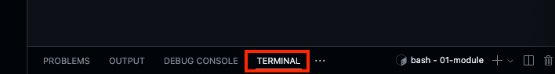

      - Type the following to download Ollama.
curl -fsSL https://ollama.com/install.sh | sh

This curl (Client URL) command fetches the installation script from https://ollama.com/install.sh and runs it. Be cautious when running such commands, especially from unknown sources, as they can execute any code on your system. Always ensure the source is trustworthy.

- curl: This is a command-line tool for transferring data with URLs.
- -f: This option tells curl to fail silently on server errors.
- -s: This makes curl operate in silent mode, meaning it won't show progress or error messages.
- -S: When used with -s, this option makes curl show an error message if it fails.
- -L: This option tells curl to follow any redirects.
- https://ollama.com/install.sh: This is the URL of the shell script you want to download.
- | sh: This pipes the downloaded script to the sh command, which executes it.

      - After the download has finished, type the following in the terminal.
ollama serve
The command is used to start the Ollama service on your local system. This command makes Ollama accessible, allowing you to interact with it and run various language models

      - Visit the Ports tab and access the URL. You can see the Ollama is running.
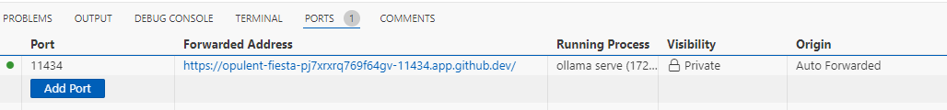
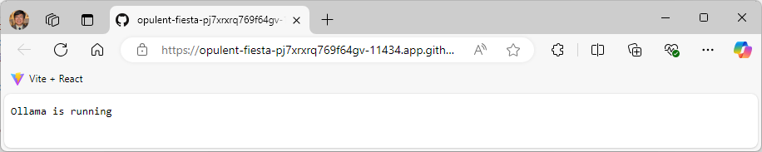
- Pull and Chat with a Large Language Model (LLM) Conversational AI.

- Open New Terminal

- Type the following in the terminal (Use Your preferred LLM model)
ollama pull gemma2:2b

The command is used to download the Gemma 2 model with 2 billion parameters from the Ollama library. For example,

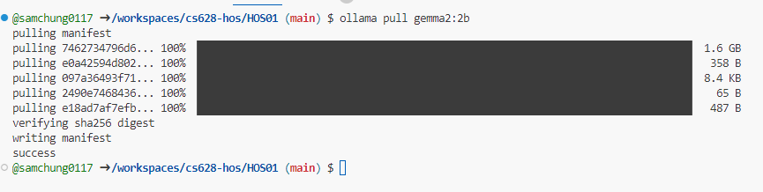

- Run ExpressJS Backend Server.

- Open New Terminal

- Type the following in terminal.
mkdir backend
cd backend

Before moving add, let’s add a .gitignore file as we usually don’t add node_modules folder as part of version control.
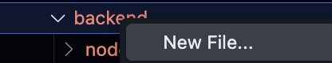
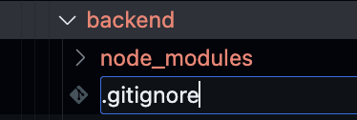

Why? The file size can get very large and it’s not optimal to host it over the internet. We let other users or systems install their own node_modules folder as defined in package.json, which will be created later with npm init and npm install.

Add in the first line:
/node_modules
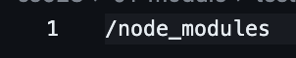

npm init -y
npm install axios cors express

- Create the “index.js” file. You can find the source code from the CS628 Repository for Examples.

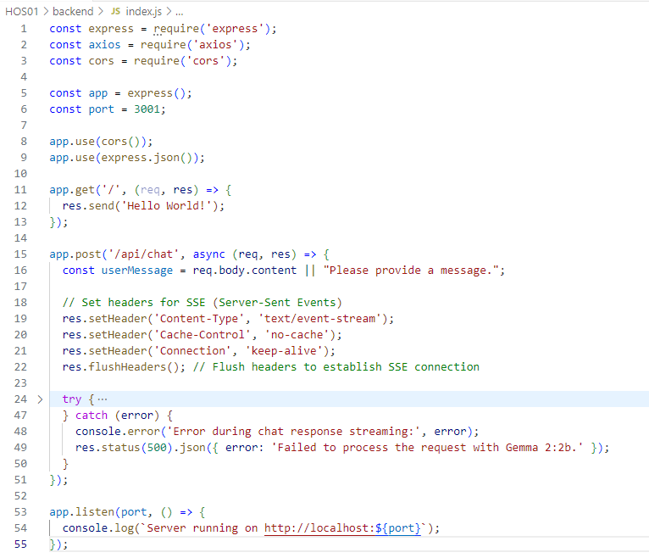

- Execute the backend.
node index.js

You should see the following in the terminal:
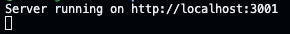

Make the Port Visibility `Public`
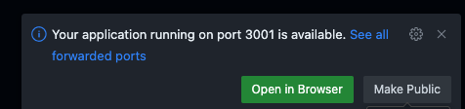
If you miss this prompt, you can still change the Port Visibility in the Ports tab.
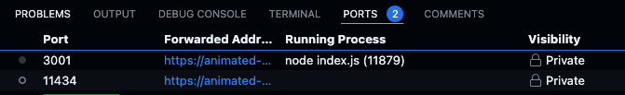
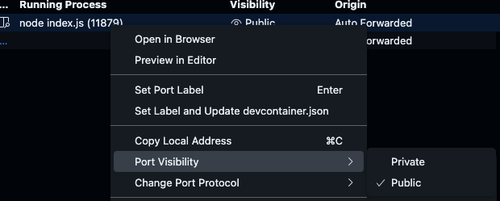

- Access the Forwarded Address in the Ports tab by hovering in the Port 3001 row and clicking the globe icon .
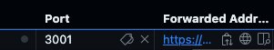

If you see this prompt, click Continue.
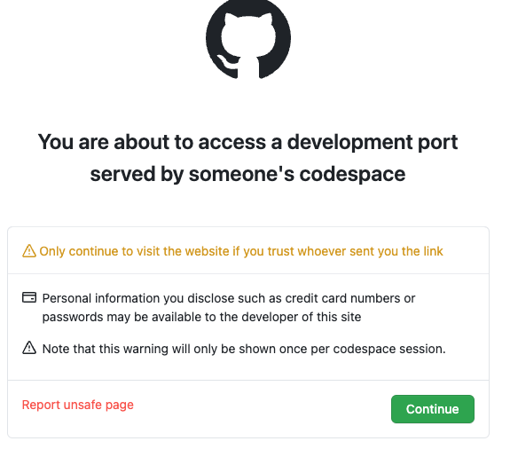

You should expect to see a Hello World text. For example,
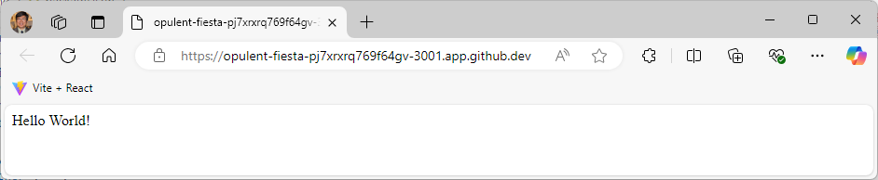

Take a screenshot of your ‘01 Hello World’ as ‘01_hello_world_firstname_lastname.png’ by using your first and last name. The URL is different from mine.
- Copy the forwarded address ExpressJS by clicking the clipboard icon .
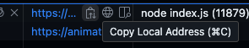

- Run React.js Frontend Server.

- Open another terminal.
- Suppose you are under the current HOS directory, HOS01.
(Caution: The screen below shows the instructor’s GitHub Codespaces.)
- Run the command “npx create-react-app frontend” to create a React app, frontend, under the HOS01.
You can see a directory called “frontend” was created by using the CRA (Create React App).
npx create-react-app frontend

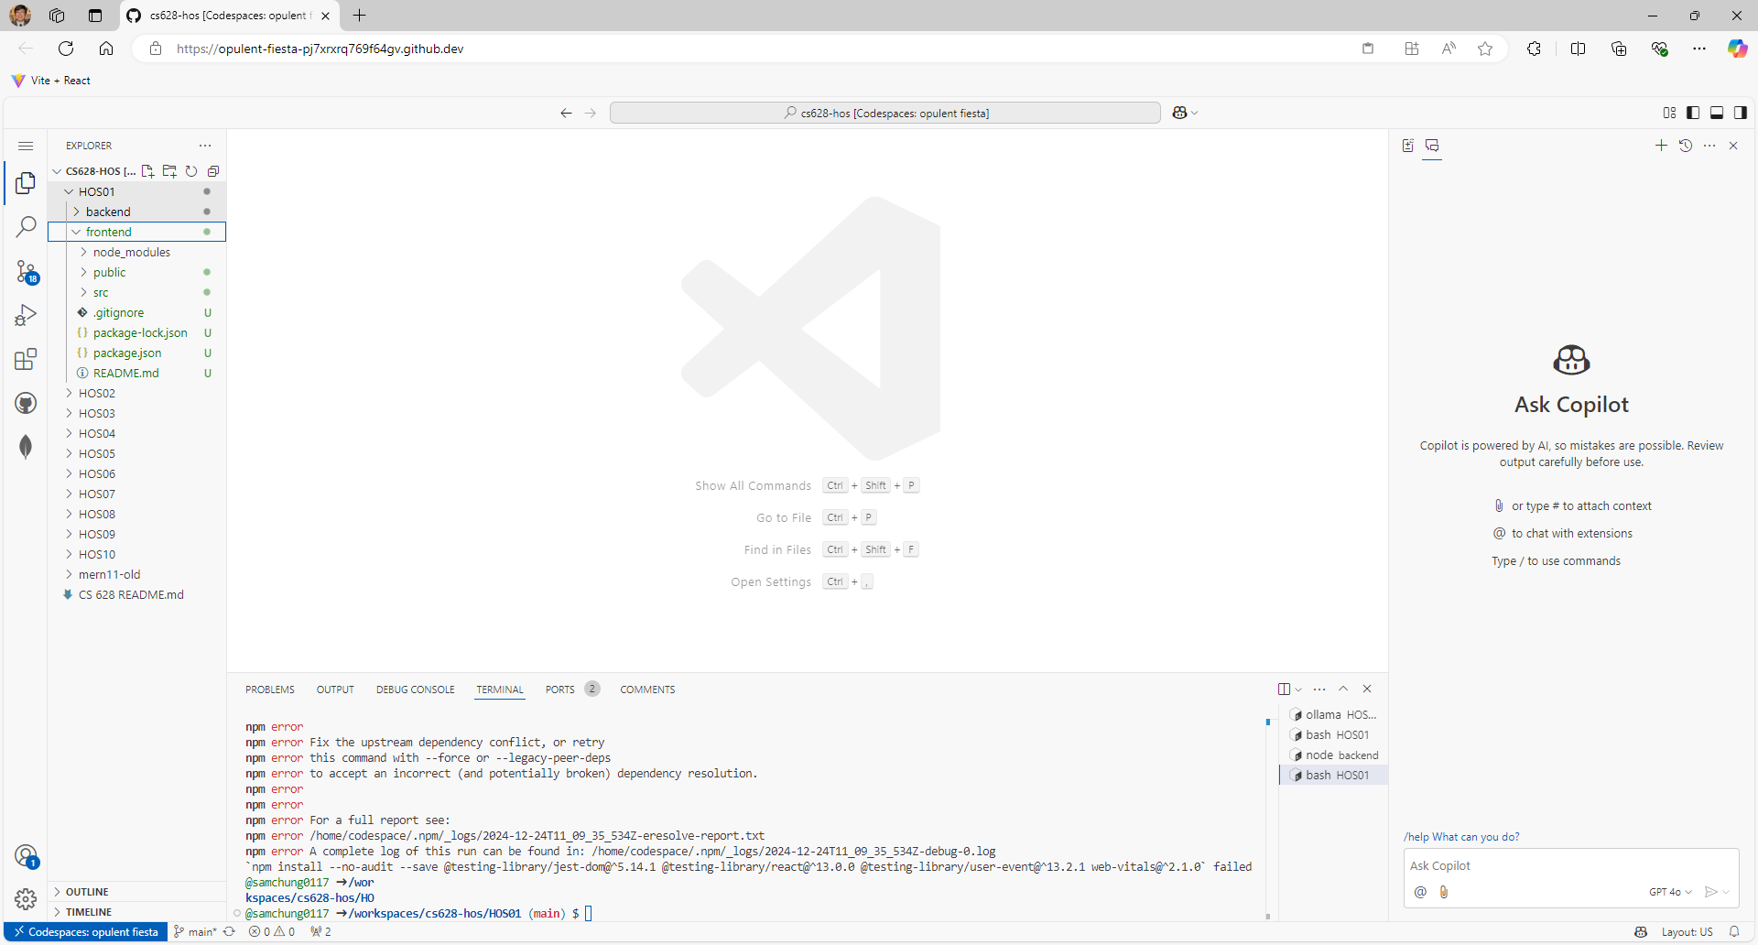

- Change the current directory to the newly created project.
cd frontend
- Run the command npm start to start the development server.
npm start
If the web app works, you can see the web app in a web browser.
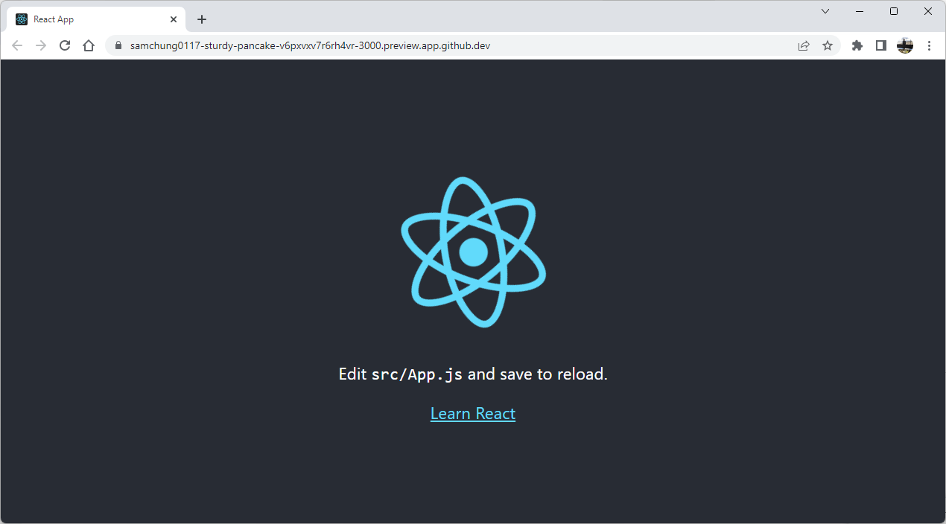

If you see an error about web-vitals:
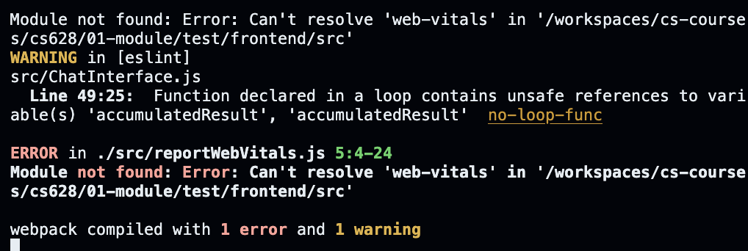
Please cancel the running terminal with Ctrl + C then type and execute:
npm install web-vitals

Then try running again
npm start

- You can also visit the PORTS panel below the editor region for output or debug information, errors and warnings, or an integrated terminal.
You can select the “Open in Browser” icon.
Click it to open the client web application at the port number 3000.

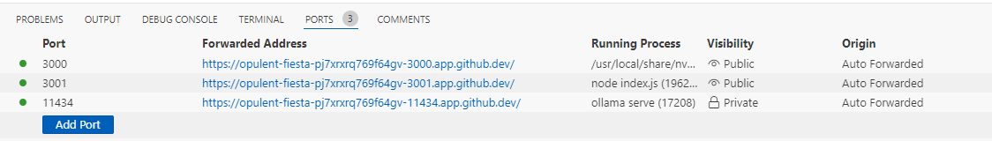

- Go to your frontend folder and right-click to create a new file.
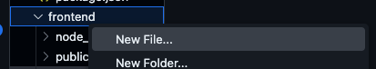

- Create `.env` file and paste the URL of your backend after `REACT_APP_API_URL=your_backedn_url/api/chat`

- Find the “App.js” file under the “src” directory. Replace its content. You can find the source code from the CS628 Repository for Examples.

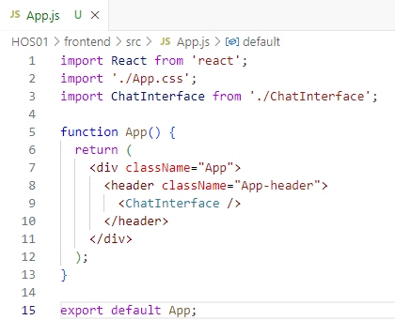

- Create the “ChatInterface.js” component under the “src” directory. Replace its content. You can find the source code from the CS628 Repository for Examples.

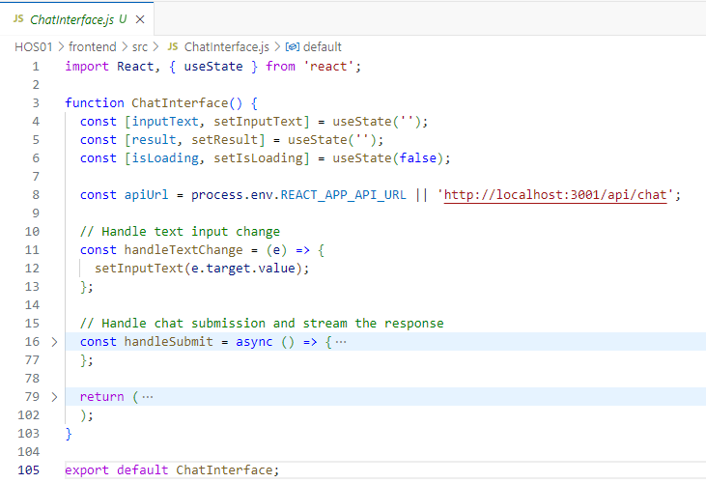

- You should expect this output in your terminal.

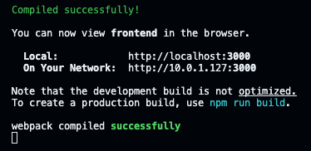

Click Open in Browser to access the frontend interface.
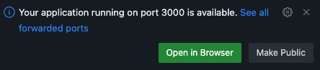

If you miss this prompt, go to the Ports tab and click Open in Browser for Port 3000.
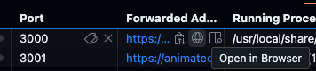

- You should see this screen. If not, refresh the web browser for the frontend. You can see the updated screen.
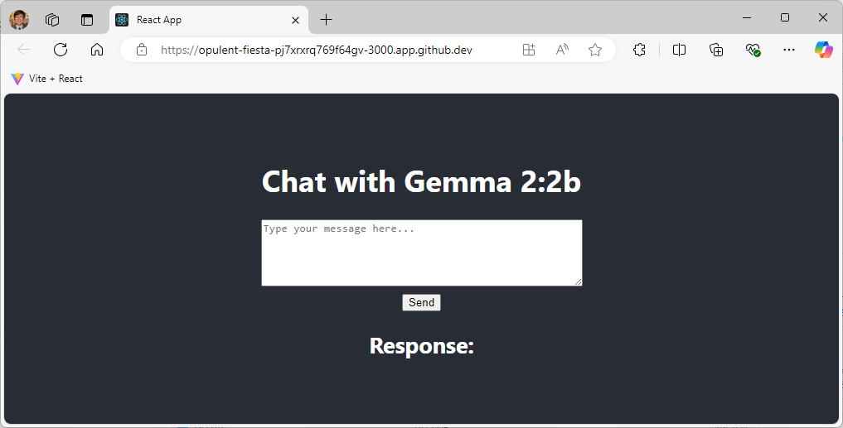

- In the textbox, type the following and click Send:

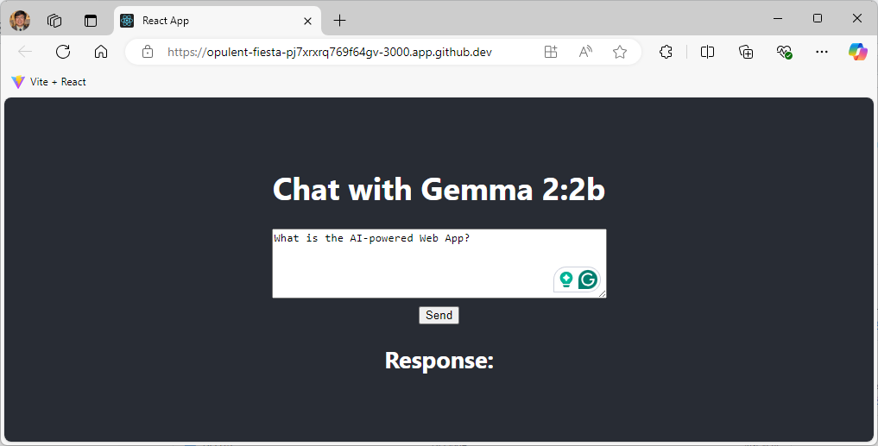

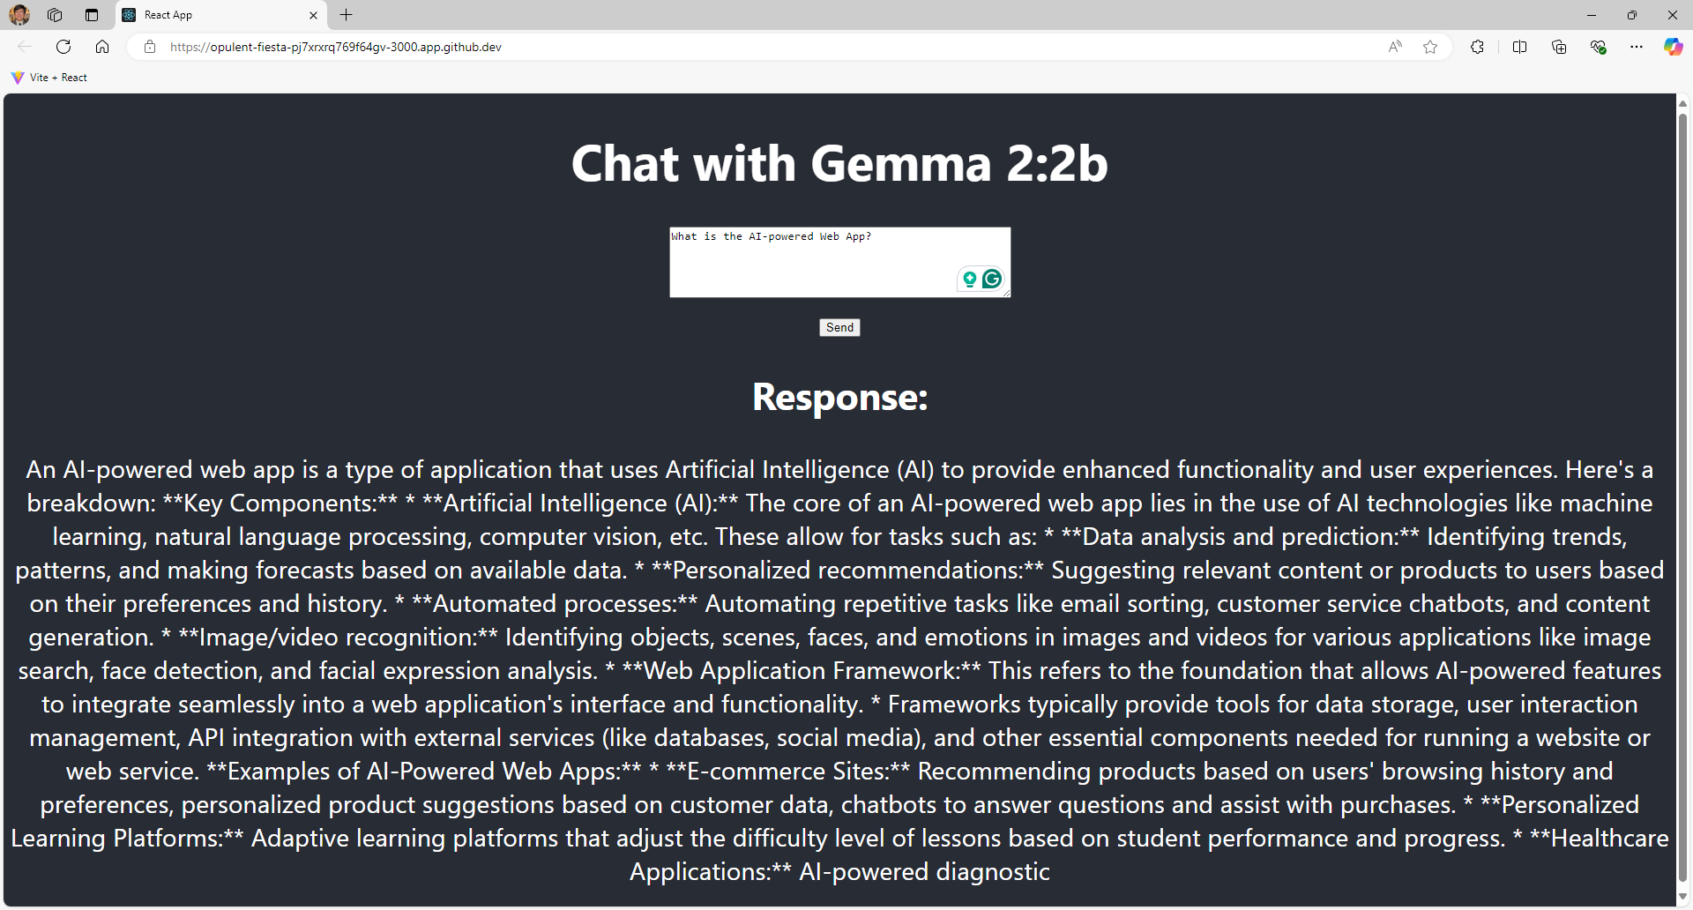

Take a screenshot of your ‘02 Chat Response’ as ‘02_chat_response_firstname_lastname.png’ by using your first and last name.

Section 3: Pushing your work to GitHub

How to submit your work in GitHub

